EYFS - Nursery
READING
Pupils should be taught to:

- Know that print has meaning and English is read from left to right and top to bottom
- Beginning to hear and say initial sounds in words and start to link sounds to letters
- Shows awareness of rhyme and alliteration
- Recognises rhythm in spoken words, songs, poems and rhymes.
- Claps or taps syllables in words during sound play
- Engages with books and other reading materails at an increasingly deeper level, sometimes drawing on their phonetic knowledge to decode words. Interpreting the text using the illustrations and their subject knowledge.

COMPREHENSION
Pupils should be taught to:
- Listens to and joins in with stories and poems, when reading one to one and in small groups.
- Joins in with repeated refrains and anticipates key events and phrases in stories.
- Begins to tell own stories and have awareness of how stories are structured.
- Talks about events and principal characters in stories and suggests how the story might end.
- Shows an interest in illustrations and words in print, digital books and words in the environment. Enjoys looking at print and digital books independently.
- Engages in extended conversations about stories, learning new vocabulary.
EYFS - Reception
READING
Pupils should be taught to:

- Continue a rhyming string and identify alliteration
- Hear and say the initial sound in words and start to link sounds to letters, naming and sounding the letters of the alphabet.
- Read a few common exception words linked to the schools phonics programme.
- Say a sound for each letter in the alphabet and at least 10 diagraphs.
- Read words consistent with their phonic knowledge by sound blending.
- Read aloud simple sentences and books that are consistent with their phonic knowledge, including some common exception words.

COMPREHENSION
Pupils should be taught to:
- Re-read books to build up their confidence in word reading, fluency, understanding and enjoyment.
- Enjoys an increasing range of print and digital books, both fiction and non-fiction.
- Describes main story settings, events and principal characters in increasing detail.
- Demonstrate an understanding of what has been read to them by re-telling stories and narratives using their own words and recently introduced vocabulary.
- Anticipate key events in stories
- Recall, reinact and discuss stories that have been read to them.
- Use and understand recently introduced vocabulary during disucssions about stories, non-fiction, rhymes, poems and during role-play.

Key Stage 1
Reading Year 1
READING
Pupils should be taught to:

- apply phonic knowledge and skills as the route to decode words
- respond speedily with the correct sound to graphemes (letters or groups of letters) for all 40+ phonemes, including, where applicable, alternative sounds for graphemes read accurately by blending sounds in unfamiliar words containing GPCs that have been taught
- read common exception words, noting unusual correspondences between spelling and sound and where these occur in the word
- read words containing taught GPCs and –s, –es, –ing, –ed, –er and –est endings
- read other words of more than one syllable that contain taught GPCs
- read words with contractions [for example, I’m, I’ll, we’ll], and understand that the apostrophe represents the omitted letter(s)
- read aloud accurately books that are consistent with their developing phonic knowledge and that do not require them to use other strategies to work out words
- re-read these books to build up their fluency and confidence in word reading.

COMPREHENSION
Pupils should be taught to:

- develop pleasure in reading, motivation to read, vocabulary and understanding by:

- listening to and discussing a wide range of poems, stories and non-fiction at a
- level beyond that at which they can read independently
- being encouraged to link what they read or hear read to their own experiences
- becoming very familiar with key stories, fairy stories and traditional tales,
- retelling them and considering their particular characteristics
- recognising and joining in with predictable phrases
- learning to appreciate rhymes and poems, and to recite some by heart
- discussing word meanings, linking new meanings to those already known

- understand both the books they can already read accurately and fluently and those they listen to by:

- drawing on what they already know or on background information and vocabulary provided by the teacher
- checking that the text makes sense to them as they read and correcting inaccurate reading
- discussing the significance of the title and events
- making inferences on the basis of what is being said and done
- predicting what might happen on the basis of what has been read so far
- participate in discussion about what is read to them, taking turns and listening to what others say
- explain clearly their understanding of what is read to them time scales.

Content Domains – Word Reading

Reception
Nursery

Content Domains – Comprehension

Reception
Nursery

Progression through Word Reading

Progression through the Framework
 | Working Towards  Uni/Multistructure | Working At  Relational | Greater depth  Extended Abstract
Nursery | - I can hear different sounds in the environment.  - I can say what is different about the sounds I can hear in the environment.  - I can recognise my name. | - I know that words have meaning. (Na)  - I know that I read from left to right and top to bottom when I am reading in English. (Na)  - I can hear rhyming words. (Nc)  - I can hear a rhythm in rhymes and songs (Nd)  - I can hear the first sound in a word (Nb)  - I can clap words when I am playing (Ne) | - I can continue a rhyming string (Ra)  - I can find alliteration (Ra)  - I can hear the first sound in words (Rb)  - I can show you what sound belongs to which letter (Rb)  - I can blend my words together (Rd)  - I can read lables, instructions, signs and envelopes when I am playing.
Reception | - I know that words have meaning. (1a)  - I can hear the first sound in a word. (1b) | - I can hear and say the first sound in words and say which sound belongs to which letter. (Rb)  - I can find alliteration (Ra)  - I can continue a rhyming string (Ra)  - I can read some tricky words (Rc).  - I can blend my sounds together to make words (Rd)  - I can say 10 diagraphs (Re)  - I can read simple sentences using my phonics (Rf) | - I can read books without decoding the words. (Y1)  - I can re-read books to build my confidence and fluency. (Y1)

Progression through Comprehension

 | Working Towards  Uni/Multistructure | Working At  Relational | Greater depth  Extended Abstract
Nursery | - I can say what my favourite book is.  - I can sing my favourite song or rhyme.  - I can say a phrase from my favourite book.  - I can pay attention when someone is reading a book and respond to the pictures or words. | - I can listen and join in with stories and poems. (Ng)  - I can tell my own story (Nh)  - I can talk about a main character from a story (Ni)  - I can talk about events in stories (Ni)  - I can say what I think will happen in the end of the story (Ni).  - I can say new words from the story (Nj)  - I can talk about a story and the pictures in it (Nj)  - I enjoy reading lots of different books (Nf) | - I can describe a main character in the story (Rg)  - I can describe the setting of a story (Rh)  - I can describe the events that happen in a story (Ri)  - I can predict what might happen next (Rj)
Reception | - I can talk about a character in the story (1c)  - I can talk about some events in the story (1c)  - I can tell my own story (1b) | - I can re-read books to build up my confidence and fluency (Rh)  - I can show that I understand what I am reading by retelling it or using new words (Ri)  - I can describe characters, settings and events in the story (Rg)  - I can say new vocabulary from a story (Ri)  - I can predict key events in stories (Rk)  - I can use new vocabulary from stories in my play (Rl) | - I can discuss what words mean and link new meanings to those that I already know (Y1)  - I can link what I have read to my own experiences (Y1)  - I can discuss why the title and events of a story are important (Y1)  - I can make inferences on the basis of what is being said and done (Y1)

Breadth of Content Coverage

 | Nursery | Reception
Autumn Term 1 | Peace At Last  Godilocks and the Three Bears  We are all different  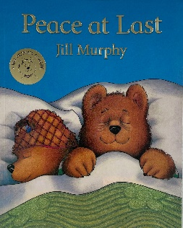  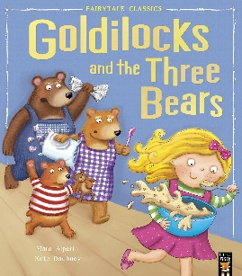 | The Colour Monster Goes to School  Stickman  Owl Babies  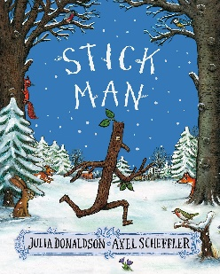  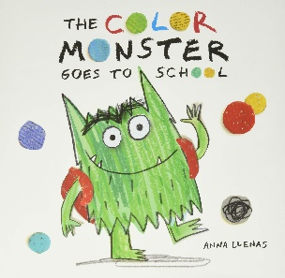
Autumn Term 2 | Dear Zoo  The Tiger Who Came to Tea  We’re Going on a Bear Hunt  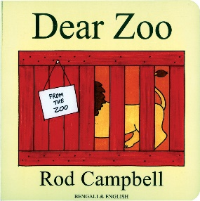  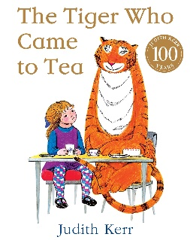 | Handa’s Surprise  Nelly Takes New York  Biblioburro  Lost and Found  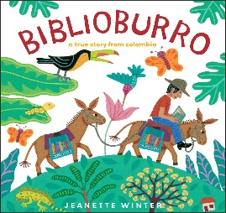  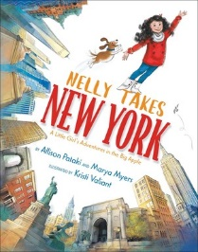

 | Nursery | Reception
Spring Term 1 | The Enormous Turnip  The Very Hungry Caterpillar  The Gingerbread Man  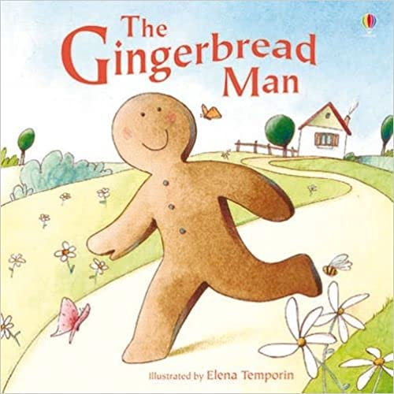  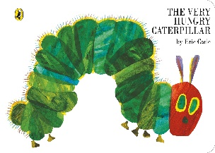 | Firefighters  Superworm  Supertato  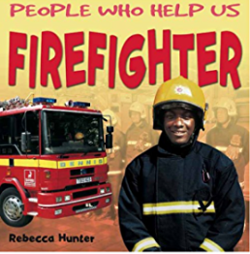  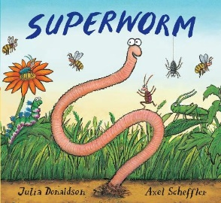
Spring Term 2 | The Very Lazy Ladybird  What the Ladybird Heard  The Very Busy Spider  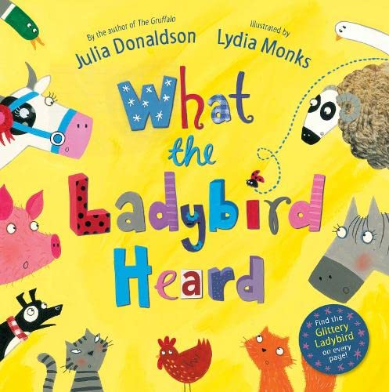  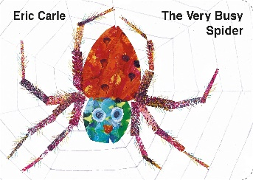 | Farmer Duck  The Crunching Munching Caterpillar  Tadpoles Promise  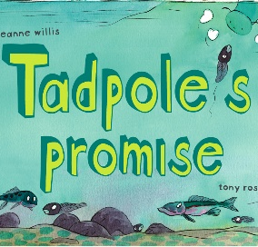  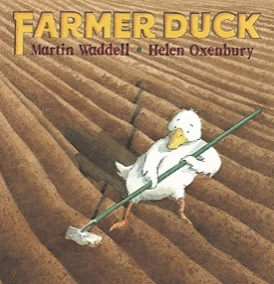

 | Nursery | Reception
Summer Term 1 | The Princess and the Pea  Little Red Riding Hood  Cinderella  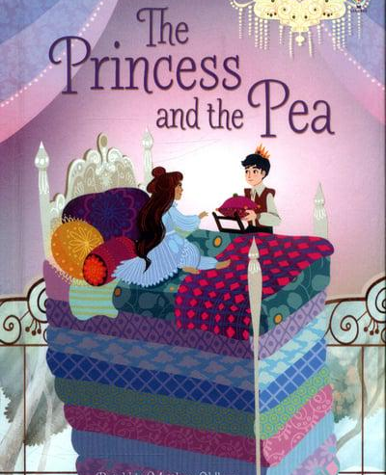  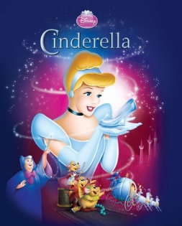 | Snow White  Rapunzel  Sleeping Beauty  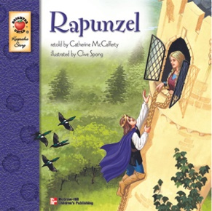
Summer  Term 2 | Barry the Fish with Fingers  Commotion in the Ocean  Under the Sea  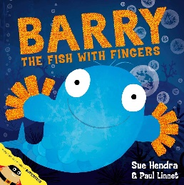  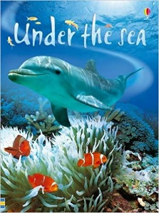 | Rainbow Fish  Percy the Park Keeper  Non – Fiction: Explorers Weather  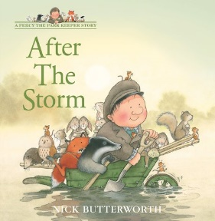  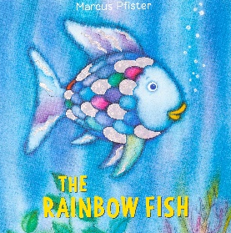

Autumn 1
 | Content Domains | Intended Outcomes
Nursery  Goldilocks and the Three Bears  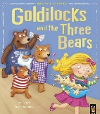  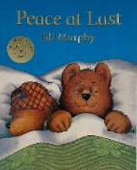  Peace at Last | Na: Know that print has meaning and English is read from left to right and top to bottom.  Ng: Listen to and joins in with stories and poems when reading in small groups. Joins in with repeated refrains and anticipates key events in stories. | WALT: Know that we learn from a book.  WALT: Know how to read a book. (Nf)  WALT: Listen and join in with a story.  WALT: Say what I think will happen. (Ni)
Reception  The Colour Monster Goes to School  Stickman  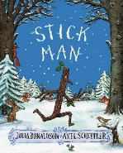  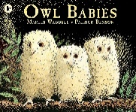  Owl Babies | Ra: Continue a rhyming string and identify alliteration.  Rb: Hear and say the initial sounds in a word and start to link sounds to letters, naming and sounding the letters of the alphabet. Reads individual letters by saying the sounds for them. | WALT: Know what alliteration means.  WALT: Find alliteration.  WALT: Find and say rhyming words.  WALT: Hear and say the first sound in a word.  WALT: Say sounds in longer words.

Autumn 2
 | Content Domains | Intended Outcomes
Nursery  Dear Zoo  The Tiger Who Came to Tea  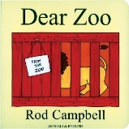  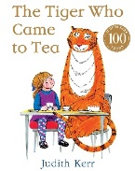 | Nb: Begin to hear and say the initial sounds in words and start to link sounds to letters.  Nh: Begins to tell own stories and have an awareness of a story structure. | WALT: Hear the first sound in a word.  WALT: Say the first sound in a word.  WALT: Tell my own story.  WALT: Tell my own story using props and puppets.  WALT: Know that a story has a beginning.  WALT: Know that a story has a middle.  WALT: Know that a story has an end.
Reception  Handa’s Surprise  Lost and Found  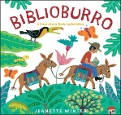  Biblioburro  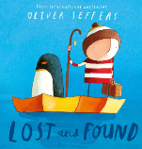 | Rc: Read a few common exception words linked to the schools phonics programme. (Rf)  Rd: Read words consistent with their phonics knowledge by sound blending. | WALT: Read some red words.  WALT: Read words using my phonic sounds.  WALT: Blend sounds together to make words.

Spring 1
 | Content Domains | Intended Outcomes
Nursery  The Hungry Caterpillar  The Ernomous Turnip  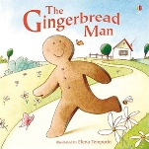  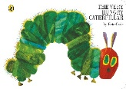  The Gingerbread Man | Nc: Show an awareness of rhyme and alliteration.  Nd: Recognises rhythm in spoken words, songs, poems and rhymes.  Ni: Talk about principal characters, settings and events in stories and suggest how a story might end. | WALT: Find a rhyme.  WALT: Find words that start with the same letter.  WALT: Find a rhythm.  WALT: Join in with a rhyme or song.  WALT: Talk about a character.  WALT: Talk about what happens in the story.
Reception  Police, Firefighers, Paramedics (NF)  Superworm  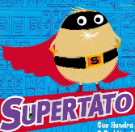  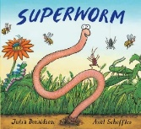  Supertato | Rg: Describes main story settings, events, principal characters in increasing detail.  Rh: Re-read books to build up their confidence in word reading, fluency, understanding and enjoyment. | WALT: Describe where the story is set.  WALT: Describe a character.  WALT: Describe some events that happen in the story.  WALT: Read a range of books.

Spring 2
 | Content Domains | Intended Outcomes
Nursery  The Very Lazy Ladybird  The Very Busy Spider  What the Ladybird Heard  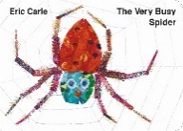  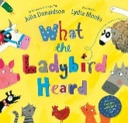 | Nj: Engage in an extended conversation about the story – learning new vocabulary.  Nk: Show an interest in illustrations, and words in print, digital books and words in the environment. (Nf) | WALT: Say new words and use them.  WALT: Talk about the pictures. (Nf)  WALT: Talk about words that I can see around me.
Reception  Farmer Duck  The Pig in the Pond  Life cycles – (NF)  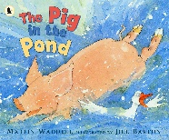  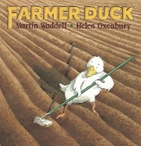 | Ri: Demonstarte an understanding of what has been read to them by re-telling stories and narratives using their own wordsand recently introcduced vocabulary.  Rf: Read aloud simple sentences and books that are consistent with their phonic knowledge, including some common exception words.  Rk: Anticipate key events in stories. | WALT: Re-tell a story using new words that I have learnt. (Rl)  WALT: Read sentences using my phonics.  WALT: Predict what will happen.

Summer 1
 | Content Domains | Intended Outcomes
Nursery  The Princess and the Pea  Cinderella  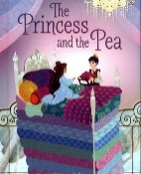  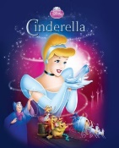 | Ne: Claps or taps syllables in words during sound play.  Nf: Engage with books and other reading materials at an increasingly deeper level, sometimes drawing on their phonetic knowledge to decode words. Interpreting the text using the illustrations and their subject knowledge. | WALT: Clap sounds in a word.  WALT: Read sounds in words.
Reception  Snow White  Rapunzel  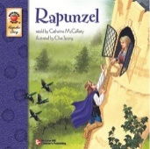 | Rf: Read aloud simple sentences and books that are consistent with their phonic knowledge, including some common exception words.  Re: Say a sound for each letter in the alphabet and at least 10 diagrpahs. | WALT: Read sentences using my phonics.  WALT: Recognise and say the special friends.

Summer 2
 | Content Domains | Intended Outcomes
Nursery  Barry the Fish with Fingers  Under the Sea  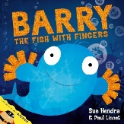  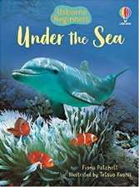 | Ni: Enjoys an increasing range of print including fiction and non-fiction.  Nf: Engage with books and other reading materials at an increasingly deeper level, sometimes drawing on their phonetic knowledge to decode words. Interpreting the text using the illustrations and their subject knowledge. Ask questions about a book. | WALT: Enjoy lots of books.  WALT: Read sounds in words and start to blend them together.  WALT: Ask questions about a story.
Reception  The Rainbow Fish  After the Storm  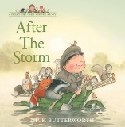  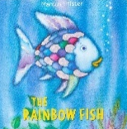 | Rl: Use and understand recently introduced vocabulary during discussions about stories, non-fiction, rhymes, poems and during role play. | WALT: Discuss what I have read.  WALT: Explain what some new words mean.  WALT: Use new words I have learnt in my play. (Ri)

Progression through Reading Band and ZPD

Set 1
Progression through Read Write Inc

Set 1
Ditty photocopies
And Ditty Books

Set 2
Green and Purple
Books

Story books contain sounds taught in previous set. This is to ensure that pupils are reading books that enable the child to experience success. We call this the ‘GOLDILOCKS Spot’ (not too easy, not too hard)

Teach Letter
Names
Pink Books

Story books contain sounds taught in previous set. This is to ensure that pupils are reading books that enable the child to experience success. We call this the ‘GOLDILOCKS Spot’ (not too easy, not too hard)

Set 3
Orange, Yellow,
Blue and Grey
Books

Read Write Inc Teaching Cycle

Pupils are assessed each half term to ensure that all pupils are assigned to the appropriate ability group.
Each set is divided into 2 phases.

- Phase 1 is taught in the first half term.
- Phase 2 is taught in the second half term.

This ensures that pupils who are repeating a phase will be repeating the same sounds in order to consolidate and embed them, but they will not be repeating the same written work or reading the same RWI reading book.

