Parent Information
Montem Academy Nursery

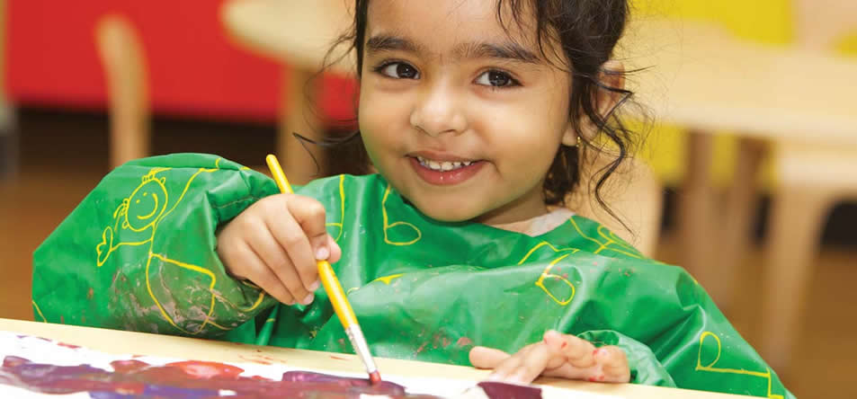

Opening Times
Morning Session: 8:30 – 11:30am (register at 9am)
Afternoon Session: 12:30 – 3:30 (register at 1pm)
Nursery Staff - Beech Class
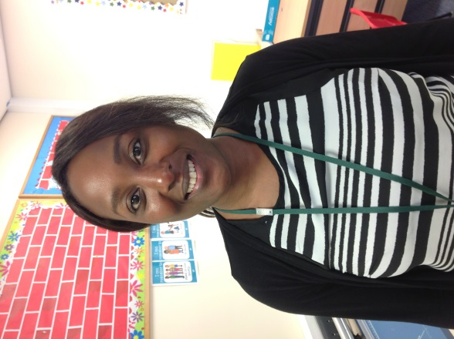
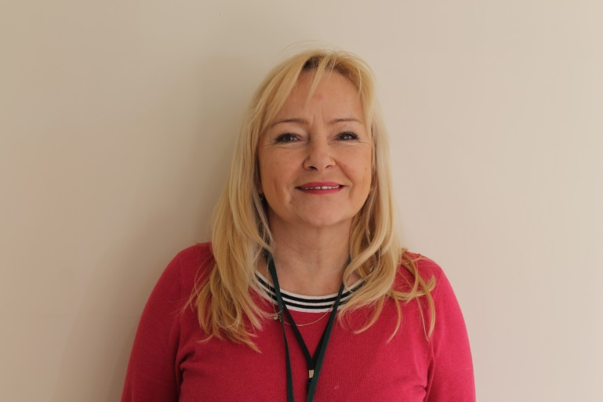

Nursery Teacher:
Mrs K. Moore

Nursery Teacher and Leader (Morning only):
Miss N. Patrick

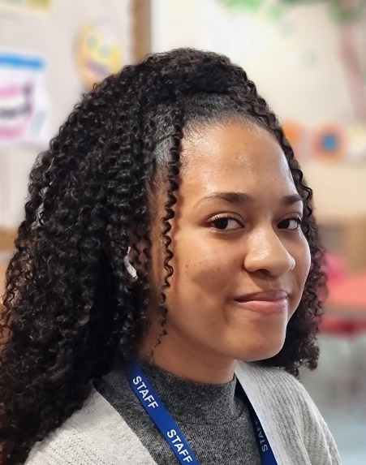

Nursery Practitioner:
Miss C. Simon

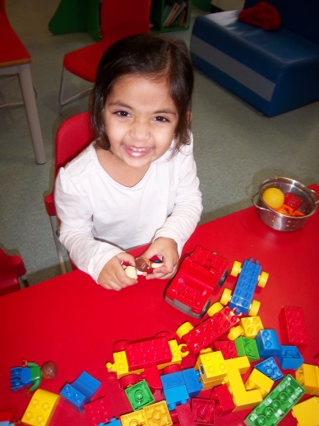
Your Child’s First Day
On your child’s first day they will stay for one hour only. Depending upon how settled your child is on the first day, we will either extend the session or continue with one hour sessions until your child has confidently settled into our nursery.
Dropping off and collecting your child
While settling your child into the nursery, at the start of the session please wait outside the nursery door until it is opened, then come in with your child and help him/her hang up their coat and settle into an activity. When collected, please wait outside until the door is opened.
It is important that you let a member of staff know at the beginning of the session if another person is coming to collect your child. If this is not done then they will not be allowed to go with the collecting person (who must be 14 or above) until their parent or guardian has confirmed this. This can very distressing for the child.

Absences, Lateness and Extending Holidays
Please phone the school on 01753 528050 if your child is absent from the nursery. If his/her attendance falls below the national average the nursery place may be withdrawn (expect in exceptional circumstances) as we have a waiting list.
The impact on a child not being picked up from school on time cannot be underestimated. It can cause increasing level of anxiety and distress. Also having an impact on staff members, as it may mean they cannot carry out duties in preparation for children’s learning. Please be onsite and ready to pick up your child. If you are running late, please phone the school and let them know. Repeated occurrences could be charged £10 an hour.
Extended holidays mage a significant impact on a child’s learning. Therefore the school strongly discourages parents from taking children out of the nursery during term time. Any requests for holidays must be authorised by the Principal – Ms Probert prior to departure. If your child does not return on the agreed date, their place will be withdrawn.
Uniform
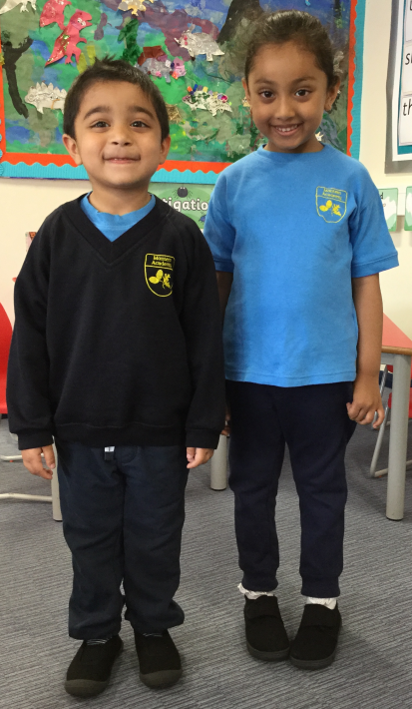
At Montem Academy Nursery our children are required to wear a uniform.

The following items will be required:
- Navy Blue sweatshirt with Montem logo
- Sky blue t-shirt with Montem logo
- Navy blue tracksuit/jogging bottoms or navy blue shorts for Summer
- Navy blue plain leggings for girls
- Plain black or white plimsolls/trainers

Please ensure that all their clothing has their name on it and placed in a named bag with a spare set of clothes and a labelled pair of wellington boots. This bag must be brought to nursery each day. If for any reason your child borrows clothes from the nursery they must be returned, washed, as soon as possible.
You can purchase the uniform from School Days Direct:
Website: www.schooldaysdierct.co.uk
Email: info@schooldaysdirect.co.uk
Telephone number: 01628 665353

Jewellery
For the safety of all the children, no child is allowed to wear any jewellery, except studded earrings. If you wish your child to wear jewellery for a religious reason please speak with a member of staff.

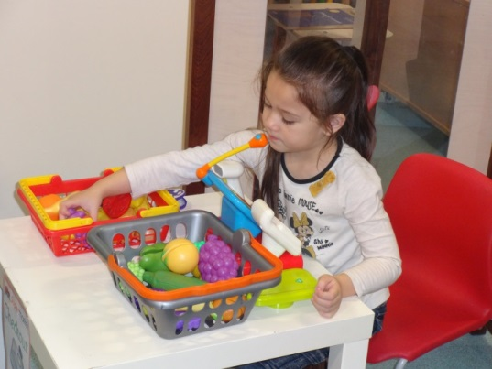
Nursery Fund – Monday Money
We have a fund built from voluntary contributions of £1 per week for each child. We use this to buy extra fruit, food and any extra equipment/resources for the children. Such as cooking ingredients.
Toys
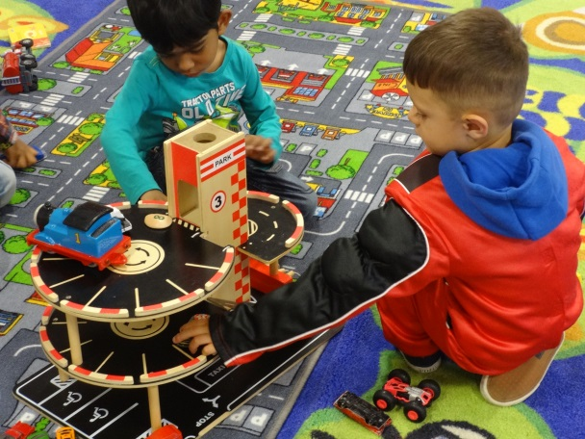
It is very common for children to ‘accidently’ take the nursery toys home, so please make sure that you check their pockets and return anything that you may find.
Please don’t let your child bring in toys from home unless requested to by nursery staff, as this can cause problems when other children want to play with them.
Curriculum
Staff plan exciting activities for children both inside and in the garden, covering all areas of the Curriculum. Children can make their own choices of activities and are also encouraged to try new ones.
The Foundation Stage Curriculum is organised into seven areas of learning: Three Prime Areas and four Specific Areas of Learning
Prime Areas: are crucial for igniting children’s curiosity and enthusiasm for learning.
Communication & Language:
- Listening, Attention and Understanding
- Speaking
The develop and use of communication and language is at the heart of young children’s learning and will be used in every part of the curriculum
- Children need to speak and listen and represent ideas in their activities
- This is particularly helped by role play
Personal, Social & Emotional Development:
- Self-Regulation
- Managing Self
- Building Relationships
Children should feel safe and secure and trust the staff who work with them
- Children should learn to respect themselves and others
- Children should develop relationships and learn about the importance of friendships
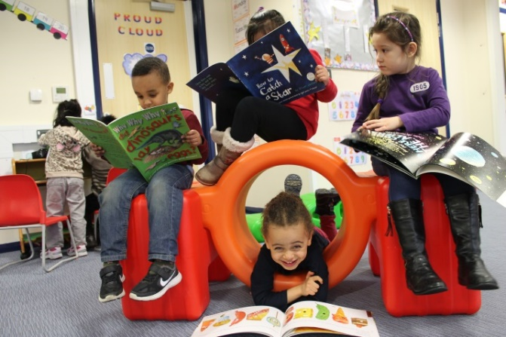
- Children should develop a positive disposition to learn
- Children need confidence to deal with challenges.
- There is a focus on encouraging healthy choices overall and an understanding of oral health.

Physical Development
- Gross Motor Skills
- Fine Motor Skills
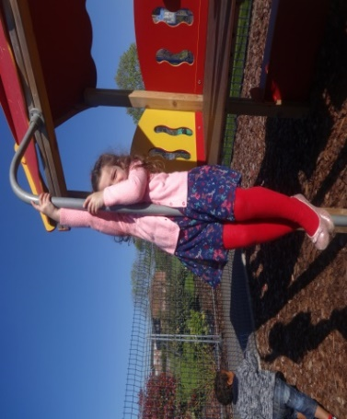
Physical development helps children to gain confidence and helps them fell the benefits of being healthy and active. Effective physical provision helps children to develop a positive sense of well-being. It includes:
- co-ordination
- control
- manipulation
- movement
The three prime areas are strengthened and applied through the Specific Areas.
Literacy
- Comprehension
- Word Reading
- Writing
Children should be immersed in an environment rich in print to encourage reading and writing skills.
It is crucial for children to develop a life-long love of reading.
Language comprehension and Word reading. Language comprehension (necessary for both reading and writing) starts from birth.

Mathematics
- Number
- Numerical Patterns
Mathematical understanding should be developed through stories, songs, games, building and imaginative play. This are of learning includes:
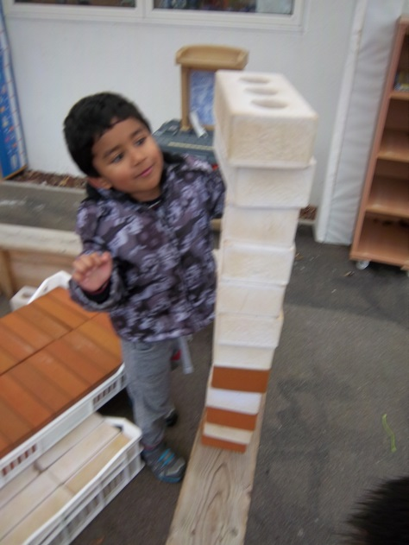
- counting
- sorting
- matching
- seeking patterns
- solving problems
- numbers
- shapes

Understanding the World
- Past and Present
- People, Culture and Communities
- The Natural World
In this area of learning children are developing the crucial knowledge, skills and understanding that help to make sense of the world. Children learn through activities based on first hand experiences. This forms the foundation for later work in science, design and technology, history, geography and ICT.
- Curiosity, discovery, problem solving all play part in early science
- Children learn about the natural world of animals, plants and people
- Children should find out about the past and present
- Children should learn about different cultures and beliefs
- This also includes, natural materials, family, the child’s life story, special events, growing / looking after plants, history, cooking and local community.
Expressive Arts & Design
- Creating with Materials
- Being imaginative and Expressive
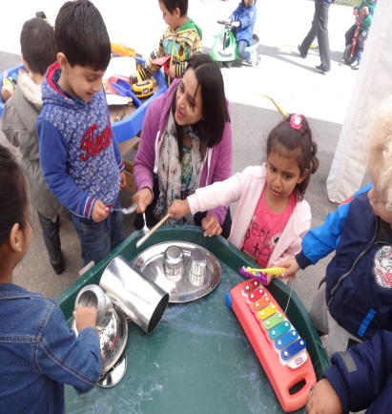
Creativity is fundamental top successful learning. Being creative enables children to make connections between one area of learning and another and so extend their understanding. It includes:
- role play
- imaginative play
- art
- dance
- music

The three Characteristics of Effective Teaching and
Learning
When we see a baby in their cot, we’re looking at ‘the greatest mind that has ever existed, the most powerful learning machine in the universe.’
We can help children become even more powerful learners through three Characteristics of Effective Teaching and Learning:
• Playing and exploring - I investigate and experience things, and ‘have a go’.
• Active learning – I concentrate and keep on trying even when I encounter difficulties. I enjoy achieving.
• Creating and thinking critically – I am learning to develop my own ideas, make links between ideas, and develop strategies for doing things.

Our Topics at Nursery
Topics depend upon the children’s’ interests. By acknowledging, and building on, children’s own interests we help children feel valued as an individual, someone who is an expert in their own life experiences.
The children will be singing songs, painting and listening to stories related to the current topic. This will help you child develop in the areas mentioned in the areas of learning.
Nursery Library
We have a library within the Nursery which your child can join after October half term. To join they will need a Book Bag, which you buy from the School Office for £5.
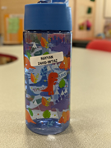
Water bottle
Please supply your child with water bottle which should have child’s name on it and refilled every day with fresh water.
No juice or sugary drinks are allowed.
What you can do at home
- Research tells us that what happens at home makes the biggest difference to your child’s early learning and development.
- Playing together, singing, enjoying books, visiting the library, painting, drawing and finding out through play about letters, numbers and shapes are important activities to do at home. These activities are learning opportunities.
- These learning activities will make a difference to your child’s learning right up to secondary school.

Some ideas to help your child’s development, you can:
- Children love to talk about all sorts of things. Make time to have back and forth conversations.
- Count things aloud, e.g. the stairs, plates, fingers
- Name colours and patterns, such as the colours of your child’s clothing or a pattern on the rug at home.
- Do other activities outside the home, e.g. visit the park, go swimming, visit a museum.
- Arts and crafts activities.
- Physical activities - It is important for your child to be physically active and to eat well.
- Explore the local area.
What to do if you are concerned
As a parent, you know your child best. Health visitors and early years practitioners have expert knowledge of child development. By working together, you can identify any difficulties your child has with their health, learning or development. If your child is struggling with learning, we can offer extra support to meet their needs.
It’s important for parents and nursery teachers to have a strong and respectful partnership.
A strong, trusting partnership will support two-way communication between you and your child’s keyperson.
‘Solutions for Health’ run Health visitor sessions by appointment only, every Monday and Thursday at the Montem Children’s Centre on Chalvey Grove. To make an appointment please phone 01753 373464.
There are always qualified paediatric first aiders on site to tend to your child in event of an accident or illness.
Mobile Phones
The use of mobile phones is not permitted on Nursery premises. Please finish your conversation before dropping off/collecting you child, as the children and staff need your full attention at these times.
Garden Activities
Staff set out equipment and this should not be disturbed.
School Policies
If you wish to view the academy policies they can be obtained by visiting the school’s website.
Contact Details Montem Academy Chalvey Grove,
Chalvey,
Slough,
SL1 2TE Telephone: 01753 528050
Fax: 01753 733036

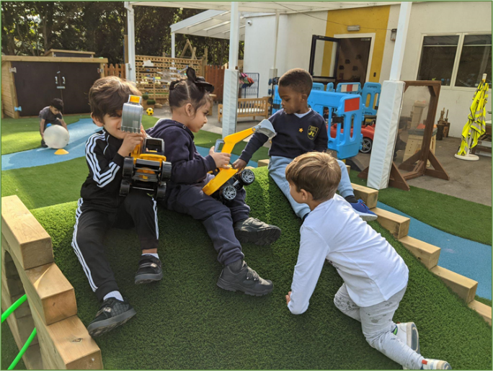
Website: www.montem.academy
Other Useful Contacts:
Montem Academy Family Support Worker (Mrs Aldridge) Offers non educational support such as toilet training / sleeping / behaviour management etc.
Look out and come along to coffee mornings, offering coffee, cake and conversations.
Chalvey Grove Children’s Centre offers a range of services for children and their families living in the Chalvey area. Please drop in and speak to the children’s Centre staff or call 01753 574387.
Slough Children and Young People’s Information Services offers free and impartial information about a range of local services including childcare and activities for your children.
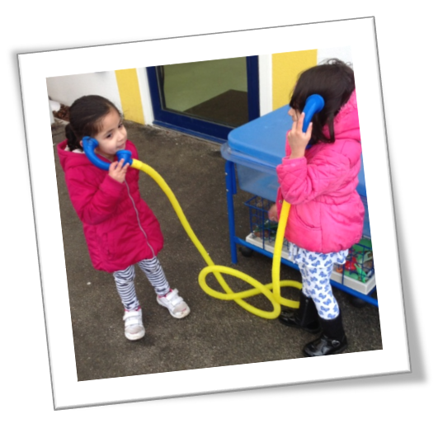
Website: www.sloughcypdirectory,org.uk
Home start is a local community network of trained volunteers and expert support helping families with young children through their challenging times.
Telephone: 01753 572958
Email: office@hsslough.co.uk
Website: http://www.hsslough.co.uk

Chalvey Grove, Chalvey, Slough, SL1 2TE entrance on Weekes Drive
01753 528050

