Nursery - EYFS
Understanding of the World (History, Geography, Science) content
Understanding the world involves guiding children to make sense of their physical world and their community. The frequency and range of children’s personal experiences increases their knowledge and sense of the world around them – from visiting parks, libraries and museums to meeting important members of society such as police officers, nurses and firefighters. In addition, listening to a broad selection of stories, non-fiction, rhymes and poems will foster their understanding of our culturally, socially, technologically and ecologically diverse world. As well as building important knowledge, this extends their familiarity with words that support understanding across domains. Enriching and widening children’s vocabulary will support later reading comprehension.
Pupils should be taught to:

Past and present
- remembers and talks about significant events in their own experience
- talk about past and present events in their own life and the lives of family members
- comment on images of familiar situations in the past
- compare and contrast characters from stories including figures from the past.

People, culture and communities
- shows an interest in the lives of people who are familiar to them
- enjoys joining in with family customs and routines
- beginning to have their own friends
- recognises and describes special times or events for family or friends
- shows an interest in different occupations and ways of life
- knows about similarities and differences between themselves and others, among families, communities, cultures and traditions.

The Natural World
- comments and asks questions about aspects of their familiar world such as the place where they live or the natural world
- talks about how things happen and why things work
- develop an understanding of growth, decay and changes over time
- shows care and concerns for living things and the environment
- explore and talk about the different forces they can feel
- look closely at similarities, differences, patterns and change in nature. Also in relation to places, objects, materials and living things
- talks about features of their own immediate environment and how environments may vary from one another
- make observations of animals and plants and explain why some things occur
- understand the effect of changing seasons on the natural world around them.

Reception - EYFS
Understanding of the World (History, Geography, Science) content
Understanding the world involves guiding children to make sense of their physical world and their community. The frequency and range of children’s personal experiences increases their knowledge and sense of the world around them – from visiting parks, libraries and museums to meeting important members of society such as police officers, nurses and firefighters. In addition, listening to a broad selection of stories, non-fiction, rhymes and poems will foster their understanding of our culturally, socially, technologically and ecologically diverse world. As well as building important knowledge, this extends their familiarity with words that support understanding across domains. Enriching and widening children’s vocabulary will support later reading comprehension.
Pupils should be taught to:

Past and present
- talk about the lives of the people around them and their roles in society
- knows some similarities and differences between things in the past and now, drawing on their experiences and what has been read in class
- understand the past through settings, characters and events encountered in books read in class and storytelling.

People, cultures and communities
- describe their immediate environment using knowledge from observation, discussion, stories, non-fiction texts and maps
- knows some similarities and differences between different religious and cultural communities in this country, drawing on their experiences and what has been read in class
- explain some similarities and differences between life in this country and life in other countries, drawing on knowledge from stories, non-fiction texts and – when appropriate – maps.

The natural world
- explore the natural world around them, making observations and drawing pictures of animals and plants
- knows some similarities and differences between the natural world around them and contrasting environments, drawing on their experiences and what has been read in class.
- understand some important processes and changes in the natural world around them, including the seasons and changing states of matter.

Progression through the Framework
Past and present
People, culture and communities
The natural world

Progression through Knowledge and Understanding
Progression through the Framework
EYFS:  Past and present | Milestone 1  Nursery | Milestone 2  Reception
- Remembers and talks about significant events in their own experience  - Comment on images of familiar situations in the past  - Talks about past and present events in their own life and in the lives of other family members  - Compare and contrast characters from stories, including figures from the past  - Talks about the lives of people around them and the roles they have in society  - Know similarities and differences between things in the past and now, drawing on their experiences and what has been read in class  - Understand the past through settings, characters and events encountered in books read in class and storytelling. | - Sharing a baby / immediate family photo with the class to talk about their own family life and the members of their family. Comment on whether or not they remember the context of the photo. Make a simple family tree with the photos, e.g. mum, dad, sibling and baby sibling. Discussions around who is older or younger. | - Developing knowledge of family trees by adding extended family e.g. grandparents.  - Compare characters from stories fiction and non-fiction as a part of our big book lessons. Are they from the past or present, pupils will explain how they know and encouraged to link to context  - People from the past – comparing different occupations from the past and now
EYFS:  People, culture and communities | Milestone 1  Nursery | Milestone 2  Reception
- Has a sense of own immediate family and relations / pets  - Imitates everyday actions and events of own family and cultural backgrounds, e.g. making and drinking tea  - Learns that there are similarities and differences that connect them or distinguish them from others.  - Showing an interest in different occupations  - Enjoys joining in with family customs and routines  - Knows that there are some similarities and difference between themselves and others and among families and communities, cultures and traditions.  - Explain some similarities and differences between life in this country and life in other countries, drawing on knowledge from stories, non-fiction texts and maps. | - Share a baby photo project. Be able to talk about their immediate family and place them on a simple family tree.  - Role play, adults modelling how to communicate and use vocabulary effectively. Having an interest in different occupations, people who help us, to role play alongside peers. (PSED, C&L). | - Exposure to cultures and traditions through our topics, e.g. Eid, Diwali, Christmas. Exposure to different traditions and families through a wide range of texts. Pupils are encouraged to compare these similarities and differences.
EYFS:  The Natural World | Milestone 1  Nursery | Milestone 2  Reception
- Notices detailed features of objects in their environment  - Can talk about some things they have observed such as plants, animals, natural and found objects  - Comments on and asks questions about their familiar world  - Developing an understanding of growth and decay over time  - Show care and concern for the living environment  - Looks closely at similarities, differences patterns and change  - Make observations on plants, animals and explains why some things occur – talk about changes.  - Understand the effect of changing seasons on the natural world around them  - Understand some important processes and changes in the natural world around them, including the seasons and changing states of matter | - An introduction to recycling, creating a project using recycled materials.  - Observations through seasons walks about their environment, animals and plants.  - Observing growing seeds  - Oral health workshop | - Pupils will develop an understanding of animals and life cycles. We will visit the farm and expand our immediate environment. Focusing on the changes through the seasons.  - Pupils are encouraged to draw on their experiences and what has been read in class.

Breadth of Content Coverage
Breadth of Content Coverage

 | Autumn 1 | Autumn 2 | Spring 1 | Spring 2 | Summer 1 | Summer 2
Nursery | Me and my family  Pupils will begin looking at their immediate family through photographs and creating a simple family tree. Talking about their lives and family members and commenting on familiar situations in their past.  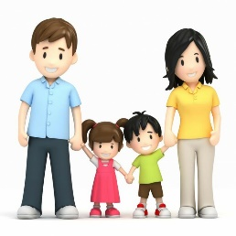  Linked literacy texts relating to family: Peace at last, Goldilocks and the three bears.  Living memory | Animals and climate  Pupils will be introduced to recycling and create an art project using recycled materials.  Topics will focus around animals and climate. Developing an understanding of which animals live in hot and cold countries around the world and why.  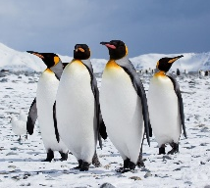  Linked texts: Dear zoo  The tiger who came to tea  Weather and natural environment | People who help us  Pupils will be introduced to different occupations, showing an interest in the lives of people around them.  Meeting different people from society, police, paramedic, fire brigade in.  Introduction to repeated phrases through linked texts: the very hungry caterpillar, the enormous turnip  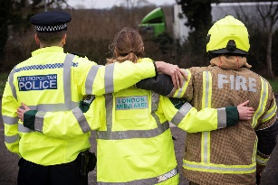  Non-fiction texts – police, firefighters, paramedics.  Living memory | Mini-beasts  Pupils will develop an understanding of changes in the environment and show care for living things around them. Pupils will use investigation resources to support their learning, magnifying glasses and binoculars.  Linked texts: The very lazy ladybird, the very busy spider, what the ladybird heard.  Focus on tripod grip and forming letters in preparation for reception.  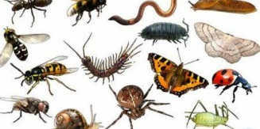  Science | Kings and Queens  Pupils will develop an understanding of the differences between themselves and other people – recognising and describing special events.  Linked texts: fairytales, the princess and the pea.  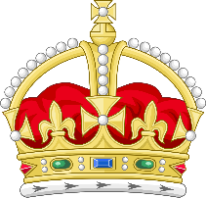  History | Under the Sea  Pupils will be introduced to different sources of water e.g. rivers, lakes, canals, oceans, as well as the plants and animals in these environments. Recognising how these environments differ from their own immediate surroundings.  Linked texts: commotion in the ocean, Barry the fish with fingers.  Non-fiction: under the sea.  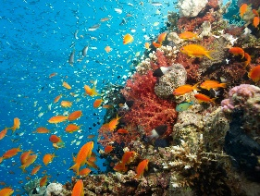  Environment
Reception | My school, my family and me  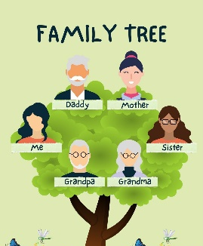  Transitioning from nursery to school and how their immediate circle now becomes larger and involves peers. More complex family tree, introducing grandparents.  Comparing similarities and differences between the past and now e.g. nursery and school life and relating this to focus texts.  Linked literacy texts: Stickman, Owl babies.  Living memory | Continents Around the World  Pupils will explore the 7 continents at surface level – in preparation for KS1. They will compare the similarities and differences between life in this country and life in other countries looking at climate, traditions, culture and religion and drawing on their experiences from our linked texts.  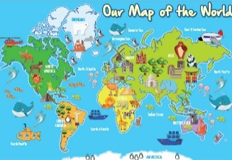  Linked texts: Biblioburro, Handa’s surprise, Nelly takes New York.  Weather and natural environment | People from the past  Pupils will talk about the roles, lives and responsibilities of people around them and their roles in society. Pupils will build on their knowledge from nursery of different occupations but compare them with the past.  Linked texts: Fiction, superworm, supertato  Non- fiction: firefighters, paramedics, vets and police.  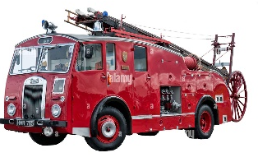  Living memory and beyond | Animals and life cycles  Pupils will explore the natural world around them making observations from animals, plants and drawing them in pictures.  Farm trip and living eggs.  Focus on life cycles.  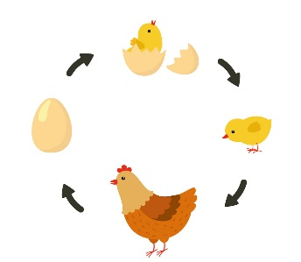  Linked texts: Farmer Duck, Crunching munching caterpillar, The pig in the Pond  Non-fiction: life cycles, caterpillars – butterflies and egg-hen.  Science – childhood promise | Kings, Queens, Princes and Princesses  Pupils will use the link texts to draw upon their knowledge of the past, talking about the lives of others and how this differs from theirs. Not just using characters to understand the past but also settings and events.  Drawing upon religious differences.  Linked texts: fairy tales, Rapunzel, sleeping beauty, snow white, Cinderella.  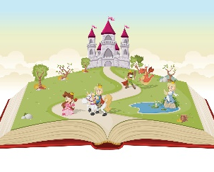  Introduction to KS1 History | The Natural World  Pupils will understand some important processes and changes in the natural world around them including seasons and changing states of matter. Pupils will cover an introduction to natural disasters at surface level.  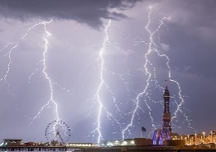  Linked texts: Percy the park keeper  Non-fiction: explorers weather, catastrophic weather.  Weather and disasters

 | Year 1 | Year 2
Weather and natural environment | Local Area  In nursery, pupils are exposed to a new environment, one that is different from their home life and introduces peers and new familiar adults. Pupils will focus on seasons and be able to talk about things they may find in their immediate environment.  In reception pupils are introduced to school as their new environment and become familiar with the immediate community around them. Their immediate circle and environment expands again. Pupils will be able to compare similarities and differences of seasons within their immediate environment.  In Year 1 pupils will explore their local environment including beyond the school including urban and rural area.  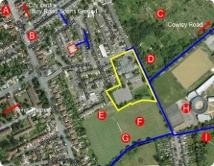  (Local Area) | Landmarks  In reception pupils explored the 7 continents. In year 1, pupils explored the seven continents in more detail.  In year 1, pupils mapped their local environment  In year 1, pupils explored the countries of the UK  In Year 2. pupils use their knowledge of towns and cities and will explore landmarks and locations within the UK  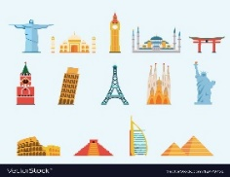  (UK- towns, cities and counties)
Countries and continents | Exploring the UK  In nursery pupils develop an understanding of which animals live in hot and cold countries around the world and why.  In reception, pupils were introduced to the 7 continents and have an understanding of how life can be different to theirs. They were exposed to things that are associated with things in that continent e.g. animals and climate.  In year 1 the pupils will build on the knowledge of landmarks- physical and human. The pupils will look at buildings founding different settlement and building that are linked to the 4 countries and their capital cities.  The pupils will also look at physical landmarks associated with the UK, mountains, rivers and seas.  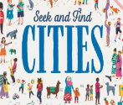  (UK- towns and cities) | Earth: Where on Earth?  In year 1, pupils explored the seven continents. In this unit of work, the pupils will be exploring the location of the continent in relation to the equator and the poles  In year 1, pupils mapped their local environment.  In this unit pupils will be using grid reference to locate and plot landmarks. Hey will also be using compasses points- north and south.  In year 1, pupils explored the countries of the UK. In this unit pupils will be locating the continents and the oceans  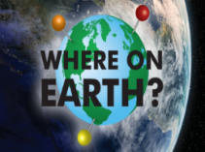
Progression EYFS to KS1 Geography

Disasters | Pompeii  In nursery, pupils are introduced to recycling and using resources to create a project. Pupils are also introduced to different sources of water such as rivers, lakes, oceans and canals.  In reception, pupils were introduced to types of natural disasters. They are able to link this into discussions about different climates and weather.  In year 1 pupils will use their knowledge of cities and towns to understand the impact of a natural disaster both on the landscape and the inhabitants.  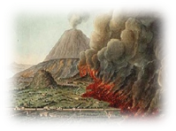 | Wildfire  Pupils will use their prior knowledge of a natural disaster and the impact it has on the environment.  Pupils will learn about locations that are prone to fires.  The pupils will use their prior knowledge of continents to begin to locate countries within the world.  (Australia)  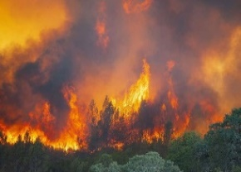

Progression EYFS to KS1 History | Year 1 | Year 2
British History | My History: Events in their own living memory  EYFS - Nursery; My history, immediate family, family tree.  Reception; extended family and putting these into simple timelines. Key significant events in their own history / living memory. Emphasis on the past and present, birthdays.  The gunpowder plot - Events that we still celebrate today  KS1; Events beyond living memory that are significant nationally  KS1: Significant historical people or events  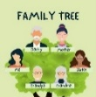  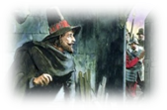 | The Great Fire of London:  Events that changed life  KS2: Developing chronologically secure knowledge and understanding of British history  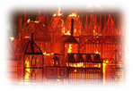
World History | World History  EYFS – Nursery; People who help us – people of significance in their everyday memory  Reception; People of the past, develop an understanding of different occupations and how they impact our society. Exploring how occupations from the past differ to now.  Significant people:  Mary Seacole, Florence Nightingale  KS1: Events beyond living memory that are significant globally  KS1 : Life’s of significant individuals in the past who have contributed to international achievements | Explorers:  World and Space Discoveries  KS2: A non-European Society that provides contrast to British History  KS2: Achievements and their influences of the earliest civilisations
Kings and Queens | Kings and Queens  EYFS – Nursery; Kings and queens. Recognising and describing special events or celebrations.  Reception; Kings, Queens, Princes, Princesses. Focus on how some people’s lives differ from ours. Roles in society. Comparing different events and celebrations. Linked texts: fairy tales.  Castle and Queen Elizabeth II: Modern Royalty  KS1: Event beyond and within living memory  KS1 : Life’s of significant individuals in the past who have contributed to national and international achievements  KS1: people and places in their locality. | Queen Victoria:  Inventions, Empires and change  KS2: Local history study  KS: Influences of significant on shaping Britain  KS2: Extending pupils knowledge beyond 1066  KS2: Changing power of monarchs

